- Consider Giotto's Lamentation from the last module, and Rogier van der Weyden's Deposition. What role does emotion play in both works? How is emotion presented and to what degree is the viewer allowed to engage in the scene? What techniques did both artists utilize to depict the scenes with a sense of realism and gravity? Discuss both works citing at least one scholarly source to support your three-paragraph analysis.
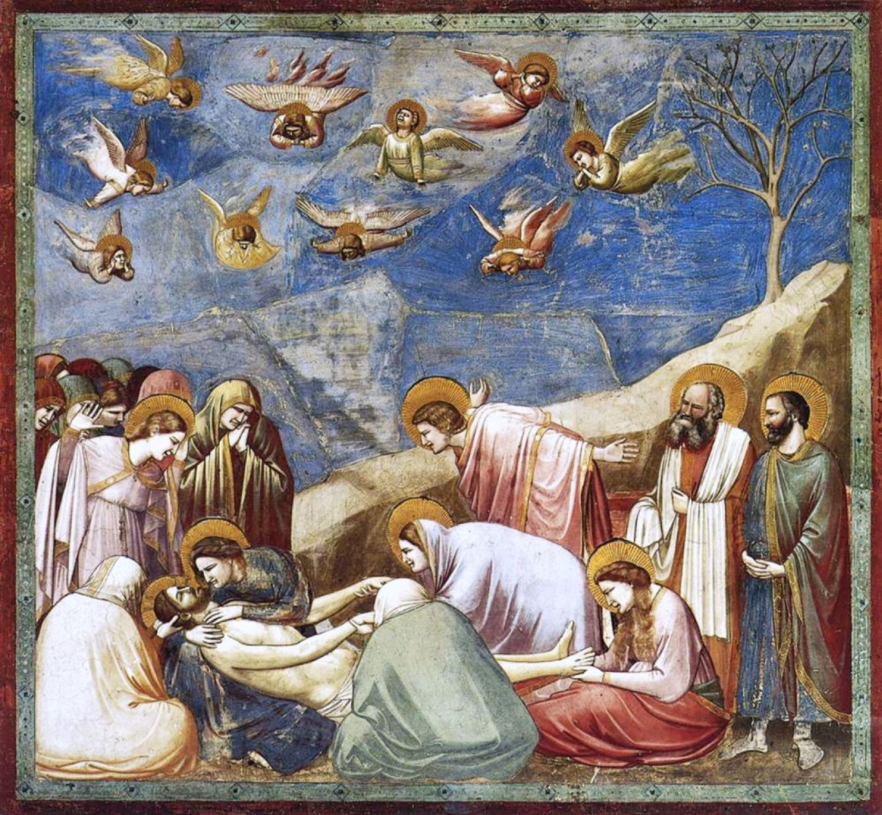
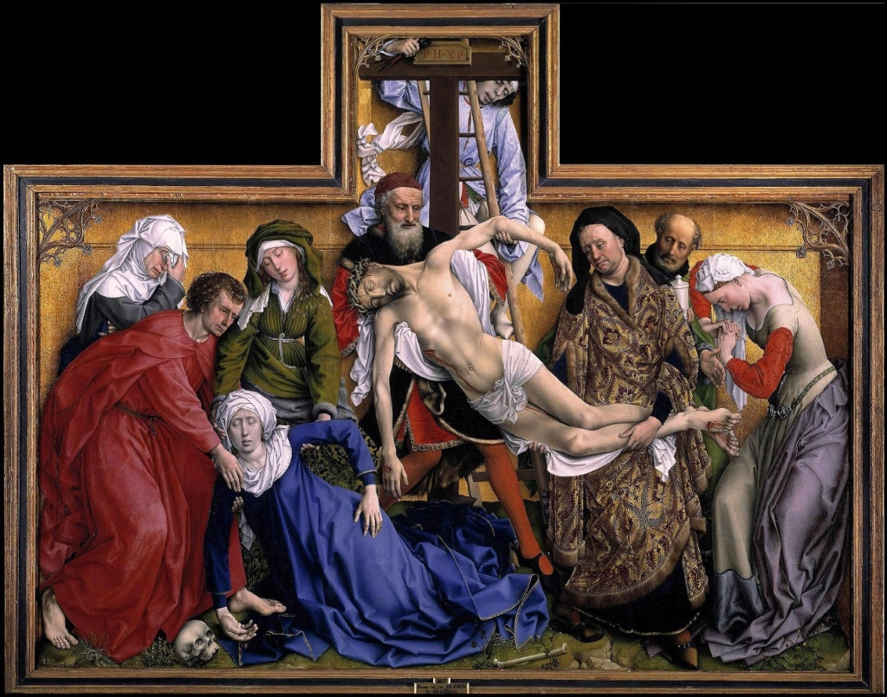

- Illusion played a significant role in the art of the Northern Renaissance. Consider how illusion was employed in at least two examples from the period. One can be a work we've discussed in the module, like the illusion featured in the Annunciation scene from the Portinari Altarpiece, but the other must be a new work that you've researched on your own.
