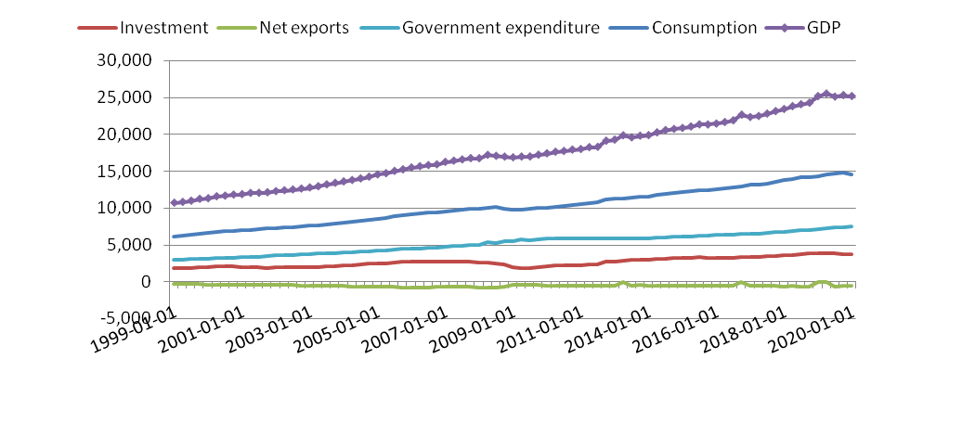

GDP is the addition of consumption, investment, government expenditure and net exports.
Thus for example for the first quarter of 2020, GDP = 14555 + 3659 + 7522 - 527 = 25209

Thus the GDP is sum addition of all these components and is the purple line right on top.
A dip in GDP signifies recession and a pick up signifies expansion.
Thus till 2007, the GDP is growing, showcasing an expansionary phase, after which it dipped signifying a recession which the economy faced.
And again started to pickup, showcasing a steady growth thereafter till 2020 until the pandemic.

