ECO 201 Project Template

[Throughout this template, replace the content in bracketed text with your own responses, and deleted any bracketed instructions (including these).]

[The Introduction section of your report is provided and should remain standard in all submissions.]

[The placeholders for your data visualizations (e.g., charts, graphs, and tables) should be replaced with the appropriate indicated images in each case. To create an isolated image from the simulation data, it is recommended that you use a snipping tool to copy and paste your data visualizations into this template. SeeHow to Use the Snipping Tool (Beginner’s Guide)for more information if you use a PC. A captioned version of this video is available: How to Use the Snipping Tool (Beginner’s Guide) (CC). Or, see Is There a Snipping Tool for Mac?.]

Memo
To: My Business Partner
From: [Insert your name]
Date: [Insert date]
Re: Microeconomics Simulations

Introduction

This memorandum report identifies and explains key microeconomic principles using a set of simulation games. The outcome of these games illustrate how microeconomic principles can be applied within real-life situations to help us make better business decisions. This report is a summary of the simulations I played and their results, which include the key takeaways and their significance, for your review and reference.It is divided into the following sections:

- Comparative Advantage
- Competitive Markets and Externalities
- Production, Entry, and Exit
- Market Structures (including the Price Discrimination and Cournot simulations)
- Conclusions
- References

Comparative Advantage

[Replace this area with the Production Decisions graph.]
Figure 1.1

[Replace this area with the Production and Trade graph.]
Figure 1.2

[Insert your responses to the following questions: How does this simulation demonstrate how individuals evaluate opportunity costs to make business decisions? Use the Production Decisions graph from the simulation as a reference to explain what role the production-possibility frontier (PPF) has in the decision-making process.]

[Explain how comparative advantage impacts a firm’s decision to engage in trade. Would a business’s decision to trade cause a change to its PPF? Provide specific reasoning to support your claims.]

Competitive Markets and Externalities

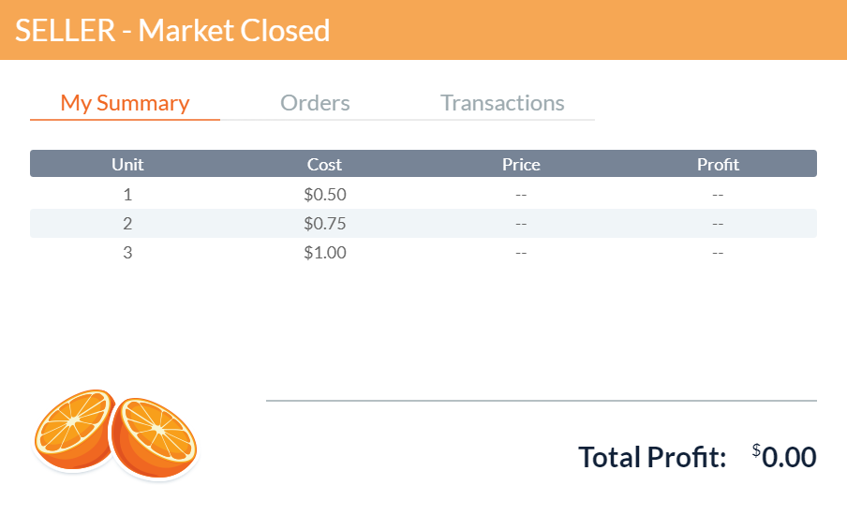Figure 2.1

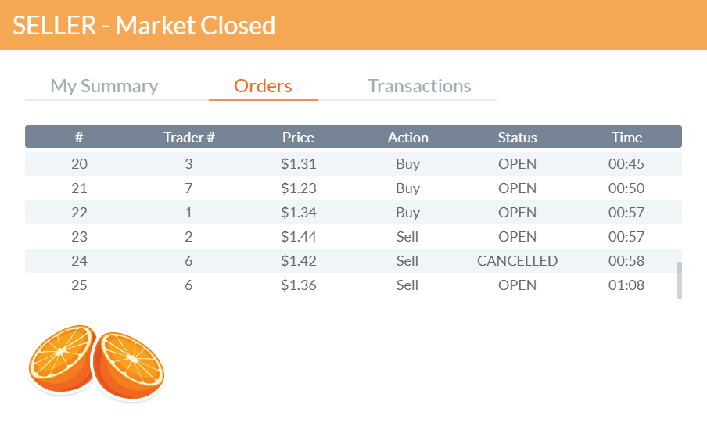
Figure 2.2

[Insert your responses to the following questions: What impact do policy interventions have on the supply and demand equilibrium for a product? Provide specific examples from the simulation to illustrate.]

[What are the determinants of price elasticity of demand? Identify at least three examples. Based on the outcome of the simulation, explain how price elasticity can impact pricing decisions and total revenue of the firm.]

[Based on the results of the simulation, can policy market interventions cause consumer or producer surplus? Explain why using specific reasoning.]

Production, Entry, and Exit

[Replace this area with the Aggregate Outcomes chart.]
Figure 3.1

[Insert your responses to the following questions: Analyze a business owner’s decision making regarding whether to enter a market. For example, what factors determined the driver’s entry and exit into the market in the simulation? Use economic models to support your analysis.]

[How does a business owner applying the concept of marginal costs decide how much to produce? For example, how did the driver determine how many hours to drive each day? Use economic models to explain.]

[How does the impact of fixed costs change production decisions in the short run and in the long run? Use the average-total-cost (ATC) model included in the module reading chapters to demonstrate this impact.]

Market Structures

[Complete the table by selecting the appropriate response from the drop-down select menu within each cell, except for the final column in which you will enter your text-based response.]

Market Structure | Number of Firms | Type of Product Sold | Price Taker? | Price Formula | Freedom of Entry? | Short-run Profit? | Long-run Profit? | Industry Examples
Perfect Competition | Choose an item. | Choose an item. | Choose an item. | Choose an item. | Choose an item. | Choose an item. | Choose an item. | [Insert two to three example industries that meet the criteria of the market structure.]
Monopolistic Competition | Choose an item. | Choose an item. | Choose an item. | Choose an item. | Choose an item. | Choose an item. | Choose an item. | [Insert two to three example industries that meet the criteria of the market structure.]
Monopolies | Choose an item. | Choose an item. | Choose an item. | Choose an item. | Choose an item. | Choose an item. | Choose an item. | [Insert two to three example industries that meet the criteria of the market structure.]
Oligopolies | Choose an item. | Choose an item. | Choose an item. | Choose an item. | Choose an item. | Choose an item. | Choose an item. | [Insert two to three example industries that meet the criteria of the market structure.]
Table 4.1

[Insert your responses to the following questions: Explain what market inefficiencies derive from monopolies and monopolistic competition. Use examples from the textbook to support your claims.]

[How do firms in an oligopolistic market set their prices? Use specific examples from the simulations or from the textbook to support your claims.]

[Explain how firms that compete in the four different market structures determine profitability. Use specific examples from the simulations or the textbook to support your claims.]

Conclusions

[Insert your overall conclusions about the relevance and significance of microeconomics. How will microeconomics principles impact your business decisions moving forward? Provide recommendations to your business partner for your future business venture.]

References

Mankiw, N. G. (2021). Principles of microeconomics(#9 edition). Cengage.

[Add other citations, as needed, in APA format].

