Questions to ask the audience
How many of you have narrowly missed an accident while driving?
Do you know the effects of microsleep while driving?
What exactly happened that you nearly got into an accident while driving?
Introduction
Most of us don't know the effect of microsleep when driving. Microsleep is a condition of sloping for a short period of 20 seconds. While driving, many things can occur just in a second. vehicles move at high speed and some recklessly. Therefore, drivers need to be alert of the road. one Sunday, we narrowly missed an accident as we were driving. I was the driver and had micro-sleep, which almost caused the accident.
Research events
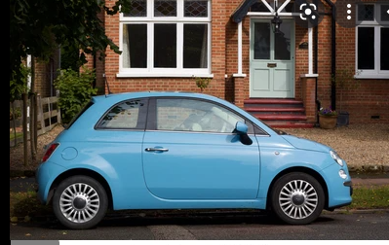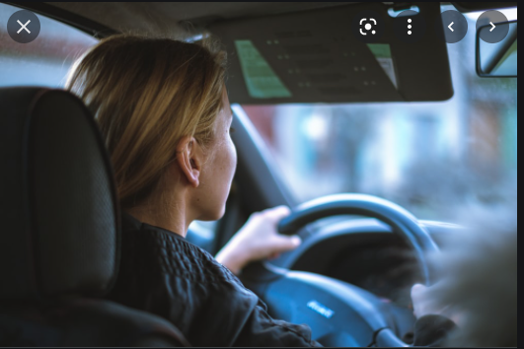

Conclusion.
Research indicates that 6400 people die annually due to drowsiness in driving. Therefore, people need to be careful on the road while driving, and they need to keep alert and avoid any disruptions. Sleeping while driving, even for a second, is unhealthy. Before an individual starts driving, ensure that you adequately sleep to mitigate the possibility of sleeping on the road while driving.

