Part A need 4pages
All part need APA style, and cited
This is an assignment for an advanced professional course
Management major only
Details are in the file, each section has special requirements
Do not share this work to anyone or upload this work in any website
Read DocA first , do not miss anything or details. If you have any question or need anything please let me know
All work is needed write in right format and no errors in grammar, punctuation, word choice, spelling.
Do not use any real name or real company name, for all work you can use “A company” without a name (No need to introduce the company in detail) or use I have Internship in a company.
use your own words to finish this or change and rewrite it, do not share this work or upload it to any website, and it has to be your original work.
Answer from the perspective of students, only internship experience

Part A
Do not use any real name or real company name, for all work you can use “A company” without a name (No need to introduce the company in detail) or use I have Internship in a company.
Use management major resources to finish this work, don’t forget mentioned all question.
Use “Beyond Teams” as the main resource, and find 4 more to cited( Beyond Teams is on the next page)
The company you can use is the ABC company, do not write too many detail,
H. E. Luccock once said, "No one can whistle a symphony. It takes an orchestra to play it."
At the dawn of human existence, the notion of teams started to develop in the form of tribes or clans, working collectively in pursuit of a shared goal. Yet, team building in the corporate world is a relatively new concept.
In corporate America particularly, there is often a resistance to teams because teamwork is viewed as the opposite of individualism. And individualism is the fundamental American culture that has supplied the motivation of America's political, economic, and spiritual activities.
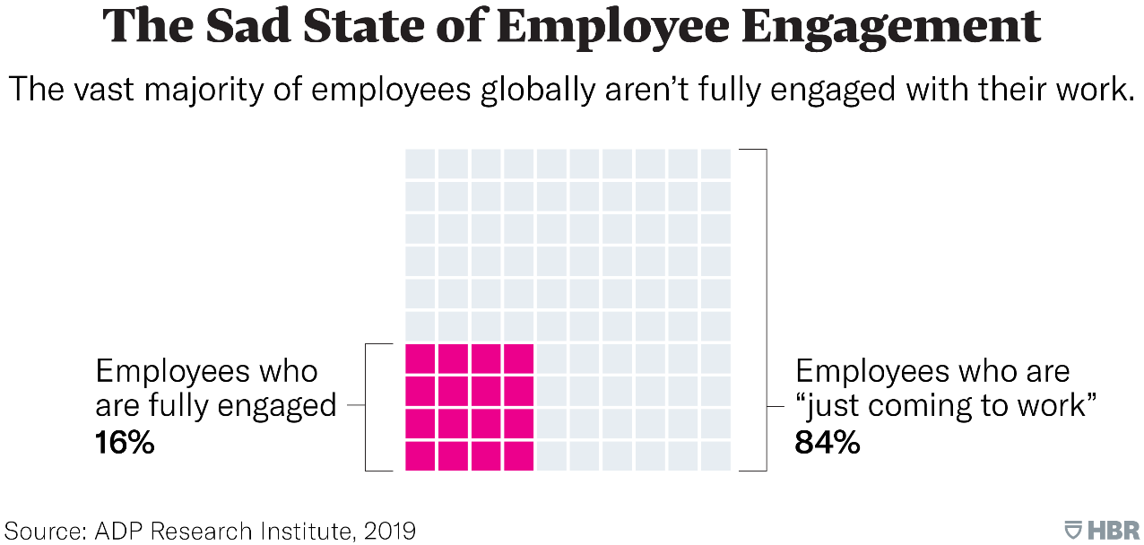
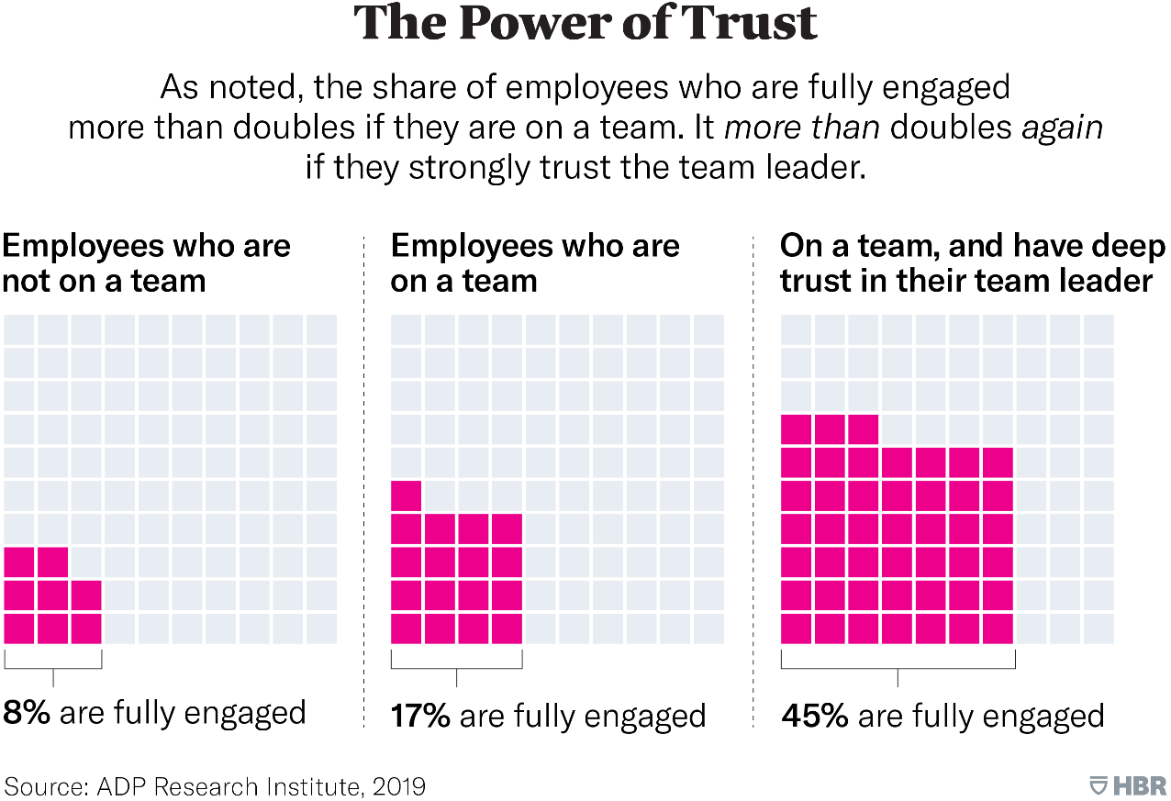
Your tasks: Please prepare a 4 pages essay to address the issues of teamwork.
- How do you justify team work and individualism? What would you say to the people who want to be "The Best and The Brightest" in the crowd ? You need to cite at least five references in APA style.
- Can you recall your best team experience in the past, either in school or at work? You may edit out sensitive and personal details to protect privacy.

  - What was the reason for the team?
  - What made it work so well?
  - Why is it so memorable?
  - What was the mix of people?
  - What was the energy level?
  - What was the outcome?
  - What have you learned about working in teams from this experience?
  - etc.

Beyond Teams
Michael M. Beyerlein, Sue Freedman, Craig McGee, and Linda Moran Summary Prepared by David L. Beal
David L. Beal is a retired Operations Manager and Vice President of Manufacturing for Lake Superior Paper Industries and Consolidated Papers, Inc., in Duluth, Minnesota. Under his leadership, the all-salaried workforce was organized into a totally self-reliant team system using the principles of sociotechnical design to create a high-performance system. Dave teaches in the Labovitz School of Business and Economics at the University of Minnesota Duluth, where his areas of interest include designing and leading self-directed team-based organizations, teamwork, and production and operations management. He received his B.S. in Chemical Engineering from the University of Maine in Orono, Maine, with a fifth year in Pulp and Paper Sciences.
INTRODUCTION
The challenges organizations face today continue to grow as a result of a rapidly changing environment, not the least of which includes the proliferation of new technology, a dynamic global marketplace, and (more recently) the threat of terrorism. Contemporary organizations must be structurally flexible, capable of adapting to changing markets, and able to compete and win on a national and frequently international scale. Collaborative work systems (CWSs) provide the fundamental principles and means to meet these challenges. Collaboration and CWSs are not new; they are simply the principles and practices that make organizations and teamwork succeed. There are 10 major principles for successful collaboration and a set of characteristics that collaborative organizations have that effectively apply these principles. Organizations that fail to embrace the CWS approach exhibit a contrasting set of defining characteristics.
Managers and employees at all levels working together can outperform individuals acting alone, especially when the outcome requires a variety of creative abilities, multiple skills, careful judgments, and the knowledge and experience that different employees possess in achieving organizational goals. CWSs are the means to achieve these goals and not an end in and of themselves.
Michael M. Beyerlein, Sue Freedman, Craig McGee, and Linda Moran. Beyond Teams: Building the Collaborative Organization. San Francisco, CA: Jossey-Bass/Pfeifïer, 2003.
RATIONALE FOR COLLABORATIVE WORK SYSTEMS
Collaborative work systems put into practice a disciplined, principle-based system of collaboration necessary to be successful in a rapidly changing environment. All organizations collaborate to some extent in order to achieve their goals, including how the organization serves its customers and meets its financial objectives. CWSs carry collaboration to a much higher level and therefore outperform organizations that do not consistently apply the principles of collaboration as a disciplined practice, or do not make collaboration the means to achieve business objectives and the goals of the organization.
Organizations that not only value collaborative practices, but consciously apply and nurture these practices with passion and conviction at all levels create a definite competitive advantage over organizations that simply assume collaborative practices will occur. Strategic direction and leadership at the top of the organization are paramount to achieving a CWS. Although team-based organizations and self-directed work systems depend on collaborative practices, these organizations may not go far enough in the degree or variety of collaboration to reach the full potential that CWSs have.
Collaborative work systems are a key strategy for achieving superior business results. Although employees create value through collaborative practices, their ability to perform and to be highly productive is often limited by the barriers the organization creates. These barriers stifle the collaborative practices employees are expected to have. Key employees at all levels solve problems, make and act on important decisions, invent new practices and improved methods of doing business, build relationships, and strategically plan for the future. The effectiveness of their processes and practices and the work system the employees are in determines the degree to which they reach their full potential. A high level of collaborative capacity will stimulate both formal and informal learning and enhance the effectiveness of work done at all levels.
When collaboration becomes both a strategy and competency for achieving business goals and a major part of the organizational culture, then:
- Organizational barriers to a collaborative work system are broken down.
- Employees at all levels know when and how to collaborate to achieve business results without wasting valuable time and resources.
- Managers and leaders in the organization create systems that are highly flexible, functionally adaptable, and fast to react to a changing environment.
- The waste that occurs within a functional silo and between functional silos diminishes and is replaced with a high level of cross-functional cooperation.
- Teams become accountable for their results and hold themselves to a high standard.
- The organization becomes a highly interdependent, interacting, and interconnected system of processes and functions that continuously performs at a high level.
Collaborative work systems do not require formal teams or a team-based system (i.e., an organizational arrangement where teams are the basic unit of organizational structure), but their collaborative capacity and competency are enhanced by the use of these structures. Because teams are frequently the most common form of business collaboration, the design, management, and work processes that make collaboration within and between teams successful are important features to discuss.
THE PRINCIPLES OF COLLABORATIVE ORGANIZATIONS
The 10 principles of collaborative work systems are as follows:
- Focus Collaboration on Achieving Business Results: Collaboration is necessary to achieve the goals and strategies necessary for long-term success. It is not an end in itself, but a means to an end. This principle focuses the organization on a common goal where everyone understands their role in the broader context of achieving intermediate and overall corporate objectives. When collaboration is focused on achieving business results, everyone is focused on common goals and objectives and is in the business of getting results with very few self-serving obstacles. Employees know what needs to be done and can go about doing it in an efficient and effective manner. When collaborative efforts are not focused on business results, conflicts and disagreements will occur and employees may suboptimize their own functional areas, sometimes at the expense of achieving overall organizational goals.
- Align Organizational Support Systems to Promote Ownership: This principle stems from an understanding that all systems of support must be congruent with the goals and principles of the organization. If a collaborative work system is a defined strategy to achieve the goals of the organization, then all systems must support the who, when, where, and why of collaborative practices. These systems include management systems, organizational design, performance management systems, and information and communication systems. Support systems that create a sense of ownership have a much greater chance of success in creating a competitive advantage. When these systems are aligned, employees are rewarded for acting in a predictable and consistent manner toward achieving individual, intermediate, and overall corporate goals and objectives. When it is not working, employees are sent mixed messages that collectively produce organizational chaos and poor performance.
- Articulate and Enforce a Few Strict Rules: This principle applies to the policies, practices, and methods that drive decision making within organizations. Everyone needs to understand what needs to be done within a framework of a few highly understood rules. These rules must be consistently applied and individuals held accountable for their application. The application of this principle gives individuals and teams of individuals a common understanding of what needs to be done without limiting their ability to accomplish it. It also allows them to break down barriers and make and act on important decisions toward the accomplishment of the goals and objectives. Organizations with too many rules suffer from inaction and an unwillingness to take risks, whereas an organization with too few rules struggles from a lack of direction and consistency.
- Exploit the Rhythm of Divergence and Convergence: This principle provides a balance between creating new and exciting ways of getting the job done, and the discipline necessary to get the job done. Both of these are processes by which participants are allowed to diverge with their ideas and generate different ways of getting the job done, and also converge to a level of agreement necessary to move forward to get the job done. Managing the process of divergence and convergence is important to goal accomplishment. The process also has a rhythm that is recognizable. As collaboration within and between teams and individuals at different levels and across functional boundaries occurs, complex activities take place toward the accomplishment of the stated goals and objectives. Each cycle accomplishes an intermediate objective that allows the next step or iterative cycle to occur. When the rhythm of divergence and convergence is effectively managed, new ideas and ways of getting the job done naturally occur, while the disciplined commitment to accomplish the objective in the expected time frame is achieved.
- Manage Complex Trade-Offs On A Timely Basis: Making timely and effective decisions requires the skills, knowledge, and a process for effective decision making. When the collaborative unit is faced with complex, interrelated, or interdependent decisions, trade-ofïs frequently have to be made between contradictory criteria or information. Managing these trade-offs for effective decision making sometimes requires specialized skills, knowledge, and information that the collaborative unit must recognize and acquire on a timely basis. When complex decisions are made on a timely basis, the collaborative unit can move forward with increased confidence.
- Create Higher Standards for Discussion, Dialogue, and Information Sharing: Collaborative processes can be very complex and highly important to goal attainment. These processes must be well managed by leaders that recognize the need for good organization, coaching, and facilitation skills. Higher standards mean that participants have direct access to relevant information, expert opinions, and advice; new and improved capabilities for effective decision making; and a sense of excitement and commitment to be involved in CWS. When the collaborative capacity of an organization is not increased through coaching or training of the participants, decision making suffers, deadlines and expectations are more difficult to meet, and participants seek a safe haven by sticking to their own opinions and perspectives. Getting “out of the box” and taking a risk will become a rare event.
- Foster Personal Accountability: When organization members are personally accountable for their own role and responsibilities in the collaborative process, the capability of the collaborative unit will improve. Accountability means that participants will build capability to achieve goals by breaking down the barriers to goal attainment, putting the goal ahead of self-serving considerations, and tackling the tasks of getting the job done with confidence, risk taking, and timeliness. Participants simply do what needs to be done and act in support of the collaborative process. When there is a lack of accountability, participants fail to acknowledge their responsibility or mistakes, and they will usually act in support of their own self-serving interests.
- Align Authority, Information, and Decision Making: This principle means that teams and participants have all the tools, including the authority to make important decisions; the skills, knowledge, and information for effective decision making; and the resources and support to act and carry out the decisions they make for effective goal attainment. When these tools are present, decisions are timely and well executed, and participants are committed with a high degree of responsibility for their participation in the collaborative unit. When authority, information, and decision making are not aligned, participants experience a loss of both support and direction, a lack of ownership in the process, and chaos or confusion when decisions and plans have to be revisited.
- Treat Collaboration as a Disciplined Process: This principle means that CWS organizations must recognize and support the principles as a strategy for goal accomplishment. Making collaboration a disciplined process requires the skills, knowledge, and training of a critical mass of participants who can pass on their expertise in successfully conducting collaborative processes. When organizations are competent at collaboration, they are able to manage multiple interdependent and interacting processes at the same time. These organizations will have good organization skills, the ability to quickly hurdle obstacles and break down barriers, easy access to relevant information, excellent communication skills, and the ability to make good decisions and act on those decisions in a timely manner. When collaboration is not treated as a disciplined process, meetings are not very productive or goal oriented, participants are frustrated by the lack of goal accomplishment, and managers with authority may try to micromanage the activities of the collaborative unit.
10. Design and Promote Flexible Organizations: The successful organization today must be quick to respond to all sorts of changing business conditions and structurally flexible in its ability to get the work done and compete in a dynamic business environment. Flexible organizations respond with different structures, both formal and informal, to maximize the speed and effectiveness of what needs to be done to be successful. The increasing complexity and dynamic nature of competing in a global marketplace requires that organizations react with different structures based on the situation. These organizations break down the barriers that traditional organizations have in a way that improves their ability to compete and respond to changing business conditions. Information and decision making are moved to those who have to take action, rather than those who control the action of others. Flexible organizations have leaders who decentralize decision making for maximum effectiveness and manage the organization with a high level of cross-functional capability. When organizations are structurally inflexible, their collaborative activities are less effective, they waste valuable resources, and decisions take a lot longer to make and implement.
APPLICATIONS OF THE PRINCIPLES
Manufacturing facilities produce tangible products from physical materials with the support of functionally based staff organizations. They have become flatter in organizational structure, more flexible in their ability to get the work done in many different ways, and faster to react to the marketplace and remain competitive. As manufacturing organizations integrate vertically and horizontally to achieve a competitive advantage, they have also integrated new work systems such as “team-based organizations,” “high-performance systems, self-reliant teams,” and “sociotechnical systems.” When properly applied, these principle-based systems can produce superior performance. All of these systems represent changes in how work is organized and how the empowerment of employees has moved leadership down to the productive process or shop floor. As organizations become flatter and more flexible, the opportunities to collaborate become more numerous. The leadership in organizations must make clear expectations of the “how” and “when” to formally and informally collaborate. The “when” occurs when more than one person is required to make a decision and when effective implementation requires the acceptance or the decision is executed by a group of employees.
Collaboration in service settings needs to occur when the skills, knowledge, and expertise needed reside in more than one employee, when the decisions or tasks are interdependent with other employees or parts of the organization, when decisions require the acceptance of a group of employees for effective implementation, and when multiple teams or areas need to share resources or have a common understanding for goal accomplishment. On the other hand, collaboration can be wasteful when there is not good direction or leadership for collaborative processes, when the practice of “command and control” of employees makes the empowerment of employees an abstract thought, and when management fails to share important information with employees or give employees direct access to information necessary to accomplish their tasks.
New product development creates unique and creative opportunities. Expertise in functional organizations is organized into silos as opposed to product- or customer-based organizing structures. Another design is the team-based model, in which integration teams oversee the coordinated efforts and assignments of new product development teams. Global pressures, the threat of declining profit margins if new products are not developed, and the time to produce new products to preempt the competition are challenges these organizations face. The question is when, where, and who should collaborate to maximize the use of the valuable resources. It is also important to establish the training, expectations, and the time frame for effective collaboration.
The 10 principles can also be applied in “ virtual work settings.” Virtual organizations are “groups of individuals working on shared tasks while distributed across space, time and/ or organizational boundaries.” They are unique in that they traverse organizational and functional boundaries that exist at multiple national and sometimes international locations. The participants in virtual settings are not located at the same site, but it is still possible to apply the principles of CWS to virtual work settings.
Conclusion
Collaborative work systems are principle-based systems that are consciously designed and nurtured for high performance. CWSs allow the creative capacities and talents of their employees to continuously increase through knowledge sharing and mutual support.
Individuals collaborating effectively in pursuit of common goals and objectives will consistently outperform individuals acting alone or in functional silos, especially when the task requires multiple skills, knowledge, different experiences, and creative abilities. As the work and the accomplishment of tasks become more complex, flexible organizational structures and collaborative practices must be carefully thought out and executed to meet the varied challenges the organization faces. When organizations apply the 10 principles of collaboration, employee ownership and involvement increase, decision making is more consistent and execution is more effective, positional power is replaced with knowledge and leadership, and employees learn and grow at a much faster rate. The organization is also quicker to respond to the business environment, more flexible in its ability to accomplish objectives in different ways, and flatter in an organizational structure that values cross-functional competencies.

