This is the textbook for my Microbiology class let me know if you have access before I order. Please included reference using the below and other outside resources.
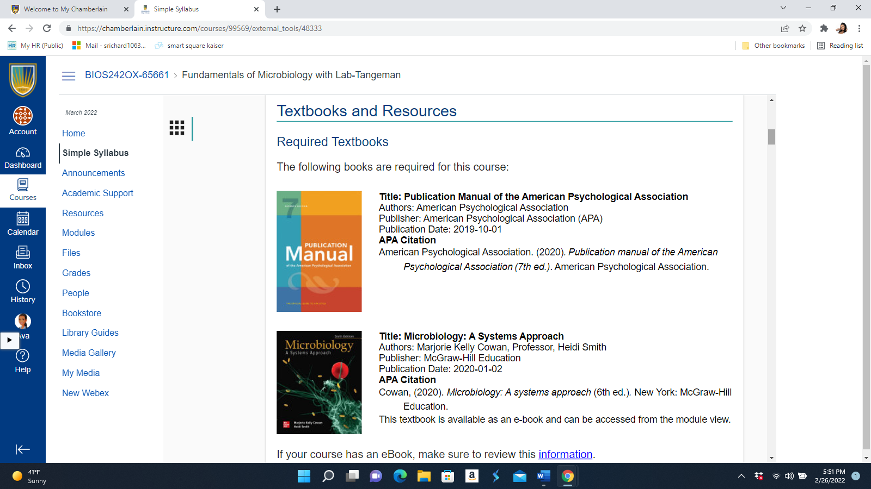

My second class is NR222 Health and wellness-Garrelts the text book that requires is print screen blow, please also use this books as references
