Virtual model in E-Business

Author
Affiliation
Course
Instructor
Due Date

Virtual model in E-Business
Question 1
E-Business the electronic business comprises all activities an organization conducts through a computer-mediated network. The organizations may include governmental, non-profit, and profit-oriented entities. These entities may involve production, customer service, and management-focused business activities (Dalevska et al. 2019). A virtual model is an online method that enables an individual to examine goods before making an actual decision to purchase them.
Additionally, it gives the ability to match goods with your needs and preferences. For instance, one can try clothes designed to look like them. There are many profits derived from this business model E-Business as follows; it saves time since the customer can make an early purchase choice before physically purchasing the item. This makes the business very fast since they don’t spend more time selecting the product again. Moreover, there is proper space utilization as there is no crowding at the physical space as this is sorted through the virtual model. In addition, this model helps an organization to have manageable employees as most customer service is catered for.
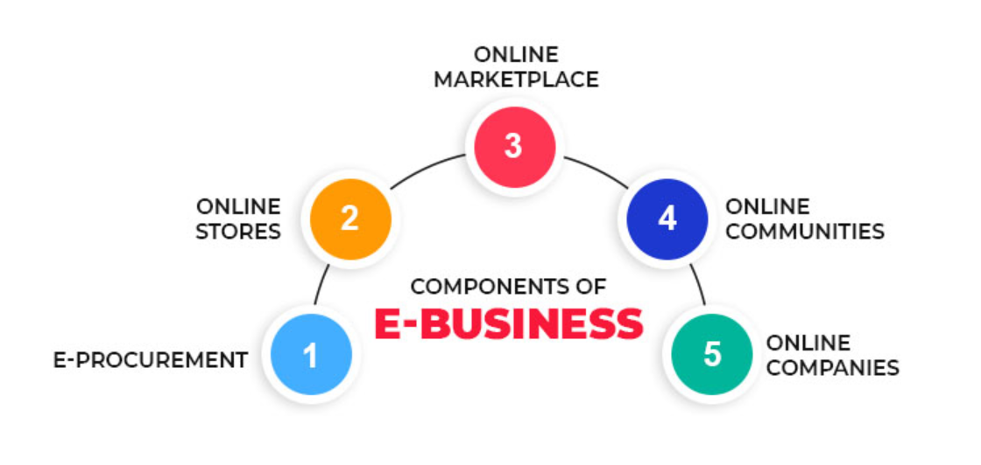
Question 2
Info product; this is usually long and detailed data on how some things operate that is given in a consumable way to information-hungry audiences. In the past days, info products were delivered as PDFs; however, recent info products have adopted the form of recorded Webinars and high-ended videos. These videos are usually designed attractively to convince the audience.
Ecommerce; involves purchasing goods and services via the internet. It is conducted through smart devices such as tablets, computers, and smartphones, among other smart devices. It usually occurs in four market segments; business to consumer, business to business, consumer to consumer, and consumer to business. In some cases, the moderator is involved in business to prevent the exploitation of one party, usually the buyer or a business, from the fraudulent consumer.
Affiliate marketing; is an advertisement system where a firm pays a person, usually bloggers, to advertise products on their behalf to generate sales. These bloggers place the adverts on social websites as apps, blogs, and many more.
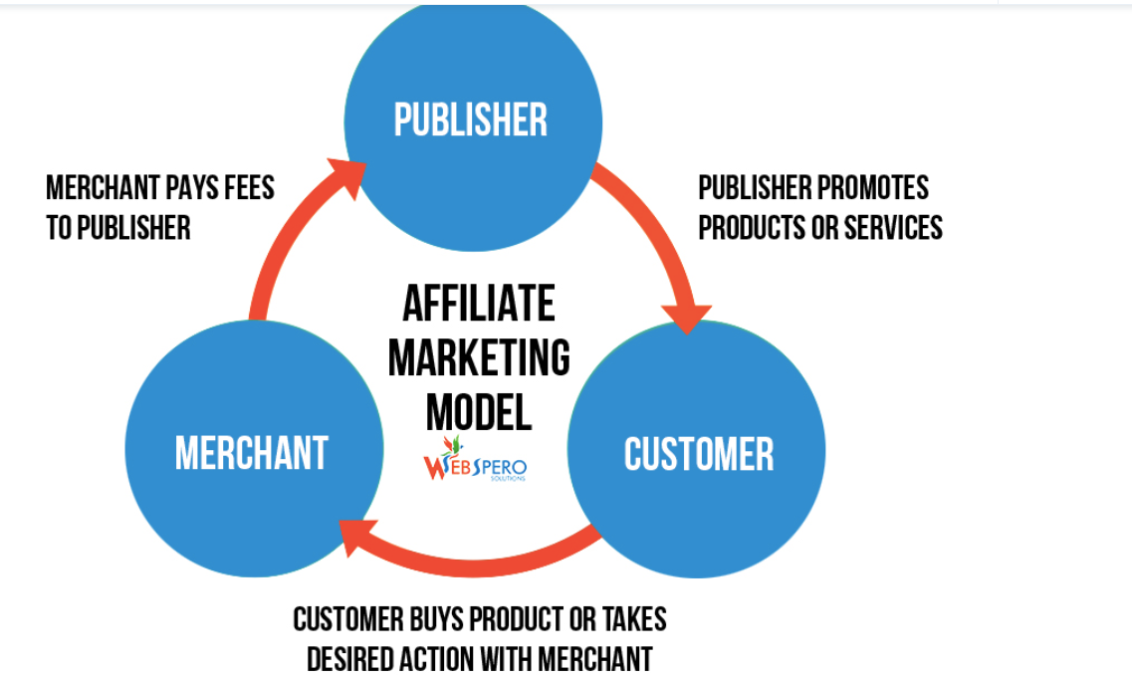

Question 3
According to my observation and personal experiences with business models, E-commerce is the best business model. There are many reasons why this model surpasses all other models known to me; first, Ecommerce allows one to achieve goods without necessarily being present, it just at your comfort zone just connecting to the internet via your smart devices and accessing a variety of goods that would be impossible under physical circumstances (Dalevska et al. 2019). Take, for example, when you need clothes, it would be easier purchasing them online just at the touch of your smart device than physically moving to the shop, moving up and down wardrobes, and changing rooms trying on new clothes, which is likely to be tiresome and time-consuming. In addition, E-commerce enhances interactions between various business partners and levels; business-to-business, consumer-to-consumer, and business to consumers that gives participants more information on existing goods and services. Furthermore, eCommerce allows one to open a shop without renting a physical space that may be too expensive, thus cutting operation costs such as storage.
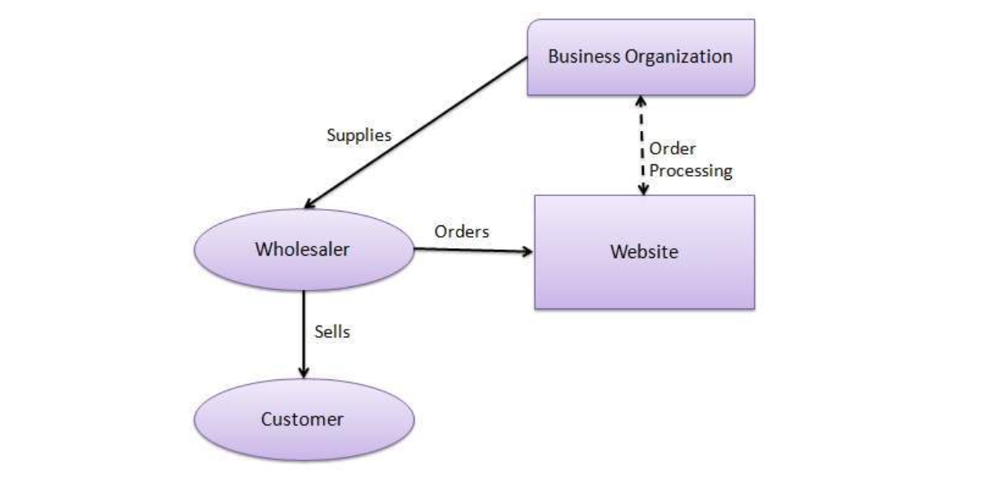

Question 4
However, much e-commerce has been adopted as the cheapest and fastest way to trade, many risks and challenges have emerged following its establishment. Some of such risks are; Low-quality goods; Customers feel much satisfied with goods that match or exceed their expectations (Priyanka & Sudha 2019). This has been a nightmare in the e-marketplaces. Sellers display very attractive videos and images of goods way better than the actual delivery. This leads to disappointments of customers and dissatisfaction cases. In addition, there are many fraudulent sellers. The sellers post goods that they don't own and disappear after the customer makes the payment, or they may continue to hold the goods in their possession even when the buyer has successfully made payment. This will lead to losses incurred by the buyer as they pay for what they don't get. One of the commonly known challenges of e-commerce is insecurity and lack of reliability due to poor implementation. Another challenge is poor user adaptation since most individuals believe in purchasing only products they can see and touch.
Question 5
The virtual organization covers a big part of the business and social environments. These environments comprise people of different ethnic, racial, religious, age, and gender backgrounds. Therefore, every e-commerce organization must abide by moral ethics and standards. For instance, violent videos and images are not allowed on social platforms as they can interrupt the normal e-commerce business into a chaotic environment; this will lead to losses by investors and a lack of understanding between diverse groups. Similarly, some content is inappropriate for underage individuals and is banned by law from featuring in social e-commerce platforms (González-Briones et al. 2018).
Moreover, there are regulations on participant privacy, anonymity, and confidentiality that have been on the alert; therefore, there have been improved restrictions to help the vulnerable participants protect their data from unsafe hands. However, E-commerce regulation has been a hard task to implement since fraudsters continue to devise even more complex methods to surpass the knowledge of regulators. Therefore there is still more to be done to enhance security in this sector.

References
Dalevska, N., Kravchenko, S., & Kwilinski, A. (2019). Formation of the entrepreneurship model of e-business in the context of the introduction of information and communication technologies.
González-Briones, A., Chamoso, P., Yoe, H., & Corchado, J. M. (2018). GreenVMAS: virtual organization based platform for heating greenhouses using waste energy from power plants. Sensors, 18(3), 861.
Priyanka, T., & Sudha, B. (2019). Issues and Challenges of E-Commerce in India. International Journal of Research in Advent Technology, 7(3), 1640-1645.

