Instruction

Part I – Use the format below to write 2 compelling Positioning statements for the brands (Sephora & Ulta Beauty)

Format:

For Target Audience that need (address the need/want), Product/Brand is category frame of reference that address the key benefits, because Reasons to Believe those Key Benefits

Example:
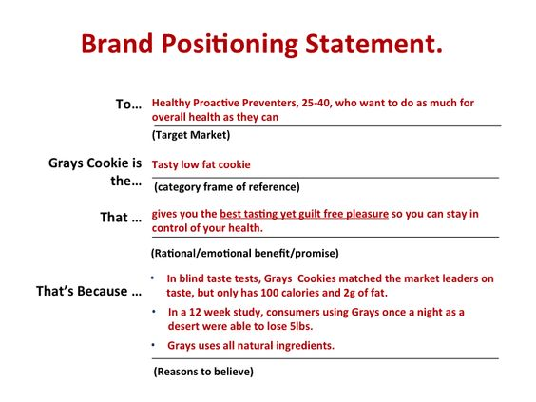
Part II (above 500 words) – Rational & Analysis: This part is to analyze how each positioning statement above build the brand equity. Statement are supported by relevant and thorough research and facts, not personal opinion.

One paragraph for each bullet point below.

- How do their target audiences differ? How is this difference reflected in the positioning statements in part I?

- What is the emotional appeal of each Positioning Statement and how do they differ from each other? How are they similar?

- How do the "reasons to believe" reflect the needs of each target audience?

Additional requirement:

- Brief intro and Conclusion
- Remember to include a list of your research sources, using the APA Citation Style.

