Deficits And Public Debt

Students: the Keynesian model concluded that government spending and taxation can be used to stimulate a recessionary economy and also use the same tools to slow demand during an inflationary period. This model suggests that the Federal government has, not only the ability to counter extreme business cycles, but also the responsibility to do so.

Ultimately, the application of macroeconomic principles can only be done in the political arena. This is the primary reason why one cannot separate economics from the political process. Inevitably, the very divergent opinions that emerge from each party are confusing at best—especially as it relates to deficits and public debt. As citizens and voters it is our responsibility to inform ourselves as best we can although it can be, and usually is, confusing.

We are at a very critical juncture in our country as we ponder how to best deal with the many economic problems that we face. The similarities to the late 1920s and the beginning of the great depression are many and ominous. Then, as now, there were fairly distinct choices—do nothing and hope that things get better, use government spending as a way to stimulate spending in our depressed economy, or conclude that balancing the budget will solve all problems. Then, as now, the argument between Democrat and Republican was heated and divisive. In recent years, the argument has focused on debt with conclusions that reducing federal debt would solve many of our economic problems and begin to reduce unemployment. With the passage of the new tax changes in 2017, and the increases in Federal spending, this logic has taken a new (but somewhat familiar turn). The conclusion that lower taxes will increase employment levels and ultimately result in more revenue for the Fed. brings us back to supply-side (trickle-down) economics and a different model. Presently, it appears that lower taxes and increased spending is resulting in a rapid increase in the deficit and public debt. The debate rages.

Without question, the Coronavirus has had a tremendous impact on the way that we look at the budget (and debt) question. We have seen a significant short term increase in public debt as we have attempted to respond to this crisis. As has been our tradition, we have turned to the Federal Government for solutions. There are simply no other entities in our system with enough power to deal with the magnitude of this issue.

Please answer (thoroughly) the questions that I have posed. I am asking for your opinion on these questions-- but informed opinions. As was the case with each Discussion Board every opinion is to be respected and email communication should reflect that.

Remember, the assignment is to communicate thoroughly and in organized fashion, your point of view. Just putting words to paper does not mean that it meets these objectives, so think about what you are attempting to convey.

QUESTIONS

- How serious is the public debt situation in the USA?
- If we paid off the debt would that solve most of our other economic problems, such as unemployment?
- How should we approach balancing our budget…spending cuts only; tax increases only; a combination of the two?
- Should wealthier citizens pay a larger percentage? How do you see our current tax policy relating to the deficit/debt situation?
- Why has concern about the debt suddenly become such a major political issue?
- Do you agree with the Keynesian Model…does government have the responsibility to try to maintain a stable economy?
- If you were an economic consultant, what would you recommend to deal with the unemployment problem? Do we still have an unemployment problem?
- The Tea Party suggests that eliminating most of government and balancing the budget would solve most/all of our economics problems. Do you agree or disagree. Why?
- How does economic growth impact the size of our debt. How do the Democrats compare with the Republicans relative to growth and relative prosperity.
- What are the similarities between personal and public debt—the differences?
- How has coronavirus pandemic impacted our view of public debt?
- How does the USA compare to other developed countries when you look at debt as a percentage of GDP. Does that percentage predict economic growth and development? See Economist Global Debt Clock, below.

Video:
http://www.pbs.org/wgbh/pages/frontline/tentrillion/view/

Wessel, Red Ink, PBS

https://www.bing.com/videos/search?q=wessil%2c+red+ink%2c+video%5c&docid=608018729076065028&mid=6EA73A9678E3B5FEE28E6EA73A9678E3B5FEE28E&view=detail&FORM=VIRE

youtube.com/watch?v=iUTMKnjZplY
ARTICLES
http://www.economist.com/node/21564410

http://www.npr.org/templates/story/story.php?storyId=99927343

Krugman:
http://krugman.blogs.nytimes.com/2016/10/22/debt-diversion- 159561&ref=headline&te=1
The Economist—The Global Debt Clock
https://www.economist.com/content/global_debt_clock

Opinion

The Economy Does Much Better Under Democrats. Why?
G.D.P., jobs and other indicators have all risen more slowly under Republicans for nearly the past century.
By David Leonhardt
Graphics by YarynaSerkez
Mr. Leonhardt is a senior writer at The Times. Ms. Serkez is a writer and graphics editor for Opinion.
•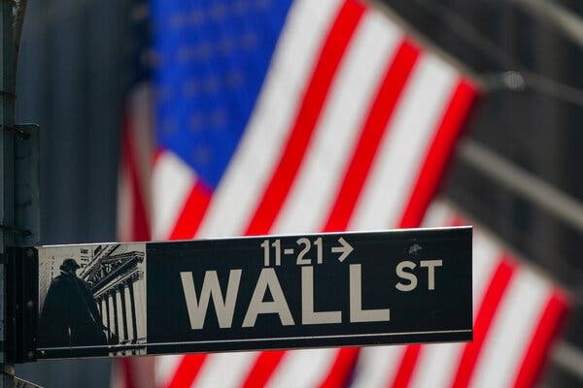
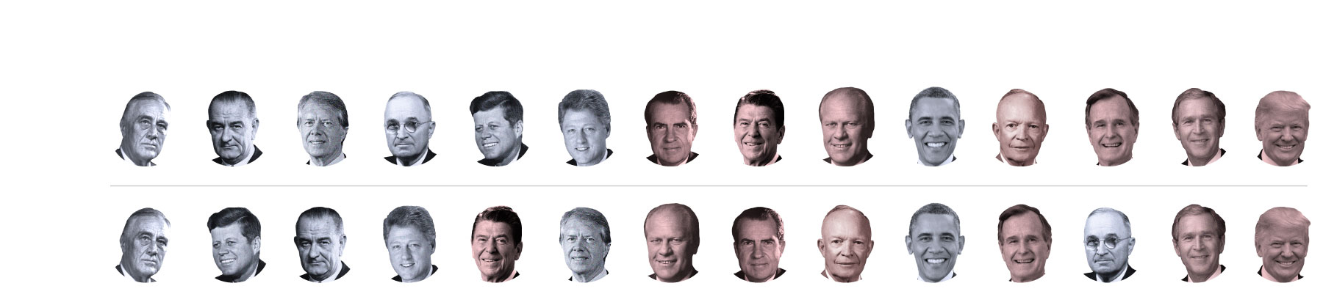
Annual growth rate from highest to lowest
#1
#2
#3
#4
#5
#6
#7
#8
#9
#10
#11
#12
#13
#14
Nonfarm
jobs
G.D.P.
A president has only limited control over the economy. And yet there has been a stark pattern in the United States for nearly a century. The economy has grown significantly faster under Democratic presidents than Republican ones.
It’s true about almost any major indicator: gross domestic product, employment, incomes, productivity, even stock prices. It’s true if you examine only the precise period when a president is in office, or instead assume that a president’s policies affect the economy only after a lag and don’t start his economic clock until months after he takes office. The gap “holds almost regardless of how you define success,” two economics professors at Princeton, Alan Blinder and Mark Watson, write. They describe it as “startlingly large.”

Annual G.D.P. growth rate
Starting president's economic clock...
Start of the term
Six months later
Year later
0%2468RooseveltKennedyJohnsonClintonReaganCarterFordNixonEisenhowerObamaG.H.W. BushTrumanG.W. BushTrump
Note: Real G.D.P. adjusted for inflation and seasonal fluctuations.·Source: U.S. Bureau of Economic Analysis.
Since 1933, the economy has grown at an annual average rate of 4.6 percent under Democratic presidents and 2.4 percent under Republicans, according to a Times analysis. In more concrete terms: The average income of Americans would be more than double its current level if the economy had somehow grown at the Democratic rate for all of the past nine decades. If anything, that period (which is based on data availability) is too kind to Republicans, because it excludes the portion of the Great Depression that happened on Herbert Hoover’s watch.
Advertisement
Continue reading the main story

Annual growth rate of nonfarm jobs
Starting president's economic clock...
Start of the term
Six months later
Year later
-1%01234RooseveltJohnsonCarterTrumanKennedyClintonNixonReaganFordObamaEisenhowerG.H.W. BushG.W. BushTrump
Note: Data adjusted for seasonal fluctuations.·Source: U.S. Bureau of Labor Statistics.
The six presidents who have presided over the fastest job growth have all been Democrats, as you can see above. The four presidents who have presided over the slowest growth have all been Republicans.
The big question, of course, is why. And there are not easy answers.
I have shown the data to multiple economists in recent weeks, and most say they are not sure how to explain it, at least not fully. “We don’t quite get why it’s the case,” Katherine Eriksson, a professor at the University of California, Davis, who specializes in economic history, told me. Marianne Wanamaker, an economist at the University of Tennessee, described the pattern to the graduate students in a class she teaches and asked for their thoughts. “They were sort of stumped,” she said.
Debatable: The sharpest arguments on the most pressing issues of the week.
Part of the answer surely involves coincidence. Some presidents, like Barack Obama and George W. Bush, take office when the economy is in a downturn, while others, like Harry Truman and Donald Trump, inherit a boom. Some, like Lyndon Johnson and Ronald Reagan, preside over military buildups; others, like Dwight Eisenhower and Bill Clinton, drawdowns. More broadly, the economy’s performance stems from millions of decisions made every day by businesses and consumers, many of which have little relation to government policy.
Still, the pattern is so strong and long-lasting that coincidence alone is unlikely to be the only explanation. Statistical noise, as Mr. Blinder and Mr. Watson wrote in their paper exploring the pattern, does not seem to be the answer.

Editors’ Picks

How to Pay for College (and Not Lose Your Shirt)

How Do We Regain Trust in Institutions?

Do We Ask Too Much of Black Heroes?

Continue reading the main story
Advertisement
Continue reading the main story
What, then, are the most plausible theories?
First, it’s worth rejecting a few unlikely possibilities. Congressional control is not the answer. The pattern holds regardless of which party is running Congress. Deficit spending also doesn’t explain the gap: It is not the case that Democrats juice the economy by spending money and then leave Republicans to clean up the mess. Over the last four decades, in fact, Republican presidents have run up larger deficits than Democrats.
That leaves one broad possibility with a good amount of supporting evidence: Democrats have been more willing to heed economic and historical lessons about what policies actually strengthen the economy, while Republicans have often clung to theories that they want to believe — like the supposedly magical power of tax cuts and deregulation. Democrats, in short, have been more pragmatic.
When Franklin D. Roosevelt first ran for president, in 1932, he did not have a fully coherent economic plan. He sometimes argued that reducing the deficit was the key to ending the Depression. Above all, though, he called for “bold, persistent experimentation.” As he explained: “Take a method and try it: If it fails, admit it frankly and try another. But above all, try something.”
Over time, he and his advisers came to champion the ideas of John Maynard Keynes. In an economic downturn, when companies and households are caught in a vicious cycle of spending reductions, the government needs to step in. The Keynesian approach has shaped Democratic economic policy ever since.
It has made Democratic presidents much more aggressive in responding to crises than Republicans. Not only was Hoover passive in the face of the Depression, but the first George Bush was slow to fight the 1990-91 recession, and the second George Bush was slow to begin fighting the 2007-9 financial crisis. Mr. Obama and now President Biden, when faced with an economic crisis, have been much bolder.
Michael Strain, an economist at the American Enterprise Institute, a conservative think tank, told me that he believed the overall partisan pattern was mostly coincidence. But, he said, “It is certainly a defensible posture that in periods of economic distress Democrats are more concerned about jobs than Republicans.”
The past year has offered another case study. Mr. Trump repeatedly downplayed the coronavirus pandemic, and the country suffered. The economy would have experienced a downturn no matter who was president, but his scattered response aggravated the pandemic and the recession. In some other countries, life is much closer to normal. In the United States, Mr. Trump became the first president since Hoover to preside over a decline in employment.
Advertisement
Continue reading the main story
The pragmatism gap isn’t only about recessions, either. Democrats have also been more aggressive about making job-creating investments — in medical research and clean energy, for example — that the private sector does not make when left to its own devices. Occasionally, a Democratic president has even been willing to go against type in order to encourage growth. Mr. Clinton, persuaded that deficit reduction could bring down interest rates and accelerate growth, scrapped some early spending plans and raised taxes. Interest rates fell, and the economy boomed.
Some past Republican presidents took a similarly pragmatic approach. Despite being conservative, both Eisenhower and Nixon were nonetheless comfortable using government to help the economy when needed. The elder George Bush signed a tax increase that contributed to the deficit reduction that, in turn, fueled the 1990s boom.
For the most part, however, Republican economic policy since 1980 has revolved around a single policy: large tax cuts, tilted heavily toward the affluent. There are situations in which tax cuts can lift economic growth, but they typically involve countries with very high tax rates. The United States has had fairly low tax rates for decades.
The evidence now overwhelmingly suggests that recent tax cuts have had only a modest effect on the economy. G.D.P. grew at virtually the same rate after the 2017 Trump tax cut as before it. If anything, the Clinton tax increase of 1993 has a better claim on starting a boom than any tax cut since.
One possibility is that the two parties are both responding to the interest groups that support and finance them, suggested Ms. Wanamaker, who worked in the White House Council of Economic Advisers during the Trump administration. But the Democratic-leaning groups (like labor unions and civil-rights organizations) may favor policies that lift broad-based economic growth, while Republican-leaning groups (like the wealthy) favor policies that mostly shift income toward themselves.
These explanations are almost certainly not complete. Much of the partisan gap remains mysterious. At the end of their academic paper on it, Mr. Blinder, a former Federal Reserve vice chairman and Clinton administration official, and Mr. Watson encourage other economists to study the issue.
But if the causes are not fully clear, the pattern is. The American economy has performed much better under Democratic administrations than Republican ones, over both the last few decades and the last century. And as Ms. Wanamaker said, “Administrations do certainly have the ability to affect economic outcomes.”
The Times is committed to publishing a diversity of letters to the editor. We’d like to hear what you think about this or any of our articles. Here are some tips. And here’s our email: letters@nytimes.com.
Follow The New York Times Opinion section on Facebook, Twitter (@NYTopinion) and Instagram.
David Leonhardt writes The Morning, The Times's main daily newsletter. Previously at The Times, he was the Washington bureau chief, the founding editor of The Upshot, an Op-Ed columnist, and the head of The 2020 Project, on the future of the Times newsroom. He won the 2011 Pulitzer Prize for commentary.

