The business model of Anna's proposal

Name
Institution Affiliation
Course Title
Instructor
Date

Introduction
Inventing Anna chronicles the rise and fall of fictitious New York heiress Anna Sorokin, who defrauded banks, hotels, New York's elite, and even her friends of cash. Anna claimed to be an heiress with a $60 million family wealth to get funding for her ambitious business concept, the Anna Delvey Foundation. Anna created an 80-page proposal explaining her grandiose ideas for the foundation, which she dubbed ADF. The proposal featured the facility she had selected, the artists and business people she wanted to be engaged with, and her specific plan for making ADF a success. She envisioned the foundation as a private, members-only environment devoted to art and luxury. It would have eateries, bars, a bakery, offices, and a hotel - and this is precisely how it is depicted in Netflix's Inventing Anna. Anna Delvey was apprehended before she could bring her concept to fruition, and therefore the Anna Delvey Foundation never materialized. The following is a diagram of Anna's business canvas.
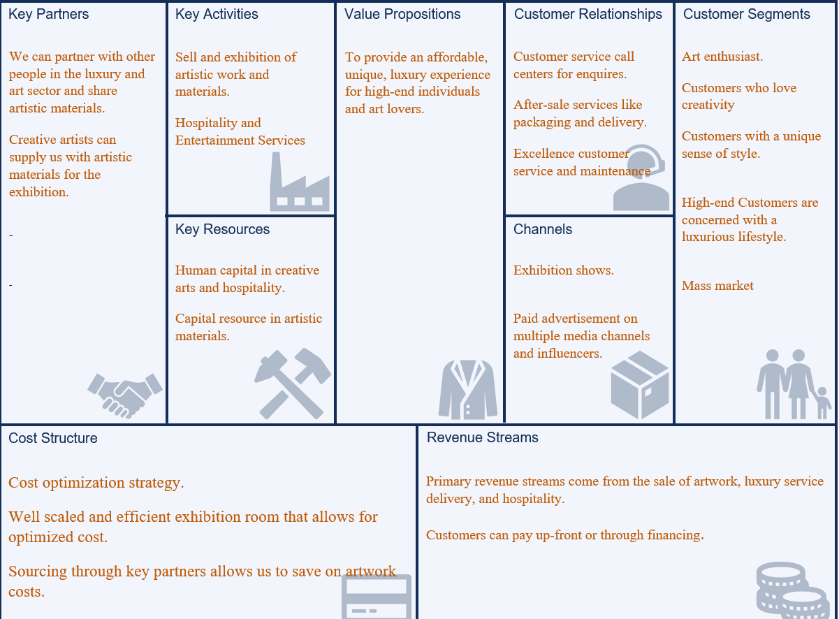
Analysis of Anna’s Business Model in Criteria for Successful Business Ideas

- Significant value
Art and luxury have a unique role in contemporary culture without question. A fine art exhibition or luxury venue may provide an open, aesthetically pleasing environment where people can examine and enjoy art while also connecting and socializing. Luxury and art are inextricably linked. This seductive romance worked as a catalyst for developing a greater brand depth via association with a distinctly creative setting. Several of the critical values associated with art exhibitions include the following:
Encouraging the development of art and artists - Whether young artists or renowned artists, art galleries acknowledge and encourage artistic potential. As a result, art gallery visitors will be exposed to new viewpoints and mindsets due to witnessing this artwork. Additionally, viewers of this art may be moved to support a cause, alter their perspective, and produce their art pieces.
Art Galleries Educate Everyone - Without a question, art pieces educate children, adolescents, and adults alike. For example, although we may read about art at a particular time in articles or on the internet, seeing the art piecesin person is much more significant. Furthermore, several studies demonstrate that individuals who have experience remember knowledge more effectively than those who just read about it in a book.
Promotes Tourism and the Economic - Excellent art exhibitions may serve as cultural hubs within cities, attracting art enthusiasts and visitors to the galleries and the city as a tourist attraction (Duxbury, 2020). Attracting visitors to these galleries may help the local economy thrive.
With this in mind, Ann's business concept is unquestionably valuable.
- Scalability
The ability to grow and the freedom to steer a firm in the direction of one's choice are both characteristics of a good business plan. It is simpler to execute a business choice to scale up and seize an opportunity when it presents itself to small enterprises. The Anna Delvey Foundation's business model is scalable due to the creative industry's market size.
- Durability
Strictly related to "maintenance," durability can be declined at social, economic, and environmental levels. Social durability refers to maintaining and replenishing the "moral capital," roughly defined as a mix of heterogeneous elements and values such as social cohesion and diversity, pluralism, tolerance, and cultural identity. Economic durability refers to the maintenance of capital in the strictest sense and the opportunity to consume over time. Finally, environmental durability refers to maintaining natural capital and the natural ecosystem. In the light of this, pursuing sustainable business development means making managerial decisions that, while preserving the company's competitiveness in the market, do not compromise the social, economic, and environmental context. If durability is to be approached, a new set of metrics needs to be adopted to assess the success of the Anna Delvey Foundation.
4.Profitability
The fine arts and luxury products industries are inextricably linked since customers of the former are often purchasers of the latter. High net worth people often surround themselves with luxury products and art pieces to convey their position and riches (Pino, 2019). With the growing number of high-net-worth people, particularly in developing countries such as China, Brazil, and India, demand for luxury items and art pieces is sure to expand. The decade's new millionaires, who travel the globe attending art shows and auction sales, have changed the auction business into a more upscale industry.
5. Marketability
Ann's company concept is marketable because luxury experiences continue to be the fastest-growing segment, owing to millennials' preference for experiences over things (Le, 2020). With the exponential rise of luxury brands worldwide, the market for art and other high-end things has changed to meet the rising demand from intelligent purchasers.
Conclusion
There is absolutely nothing wrong with Anna’s business proposal. If the project could commerce and be well-executed, then the business could be a success. The proposal seemed to have been adequately planned, with Anna involving critical individuals in the business proposal. For instance, she included architect Gabriel Calatrava, hotelier André Balazs, and restauranteur Richie Notar. The three individuals are knowledgeable, skilled, and experienced in their respective sectors, and with their involvement, the business had a chance to flourish. Additionally, Richie Notar is a co-owner of Nobu Restaurant, a successful business similar to Anna’s business idea. She also wanted exhibitions and installations from high-profile artists such as Urs Fischer and Tracey Emin and says artist Christo agreed to wrap the building. These celebrities would cause traffic at the business premises if the plan were actualized. Anna also scouted for a suitable location that perfectly fit the idea. The famous Church Missions House in New York is appropriate for that type of business since it is situated in a busy and well-developed High-end area. I would invest in technology if it were my company concept. For instance, it will develop a company website and manage sales with a point-of-sale (POS) system (Saeed, 2019). Additionally, bookkeeping, payroll, and personnel scheduling software may assist the business.

References
Duxbury, N., Bakas, F. E., Vinagre de Castro, T., & Silva, S. (2020). Creative tourism development models towards sustainable and regenerative tourism. Sustainability, 13(1), 2.
Le, N. (2020). Brand Management in Luxury Marketing.
Pino, G., Amatulli, C., Peluso, A. M., Nataraajan, R., & Guido, G. (2019). Brand prominence and social status in luxury consumption: A comparison of emerging and mature markets. Journal of Retailing and Consumer Services, 46, 163-172.
Saeed, S., Nizamani, M. A., Shaikh, A., Memon, M. A., Abbasi, F. A., & Naqvi, S. M. R. (2019). Evaluating the Quality of Point of Sale (POS) Software. University of Sindh Journal of Information and Communication Technology, 3(2), 69-75.

